Anthropology 101 Study Guide (Exam 1)

**SECTION:** Introduction to Anthropology

**Science**: A progressive, self-correcting, evidence based way of understanding the world

* **Scientific Method**: Hypothesis is stated, data is collected and the claim is either refuted or accepted
* Observation → Deduction → Hypothesis → Experimentation

**Timeline of developments in natural science**

* **Greeks**: Immutability, the organisms are static and cannot be changed
  + **Great chain of being**: a hierarchical structure of all matter and life, thought in medieval Christianity to have been decreed by God
  + There were no experiments conducted in this time
    - Nature was seen to be constant/immutable, as it was created in the image of God; there was no reason to change.
* **Renaissance:** Time of rebirth in the study of human anatomy and physiology
  + Refuted the idea of **monogenism** or there only being one creation source
  + Proposed **polygenism**, the opposite of popular religious belief
* **Taxonomy:** classification of animals
* **Uniformitarianism:** Earth’s crust was layered over time, much longer than the proposed 6,000 year timeline provided by the Church
* **Catastrophism:** Earth’s past was formed in abrupt changes, such as extreme natural disasters and famine
* **Uniformitarian:** someone who believes in uniformitarianism
* **Inheritance of acquired characteristics:** if an organism uses a particular part of their body, that effort will then be transferred to their offspring
* **Hominids:** members of the primate family
* **Adaptive Radiation:** different animals filling in ecological niches
* **Natural Selection:** animals that are are better suited to live in an environment will live on to reproduce
* **Artificial Selection:** breeders choose which traits will be passed down from generation to generation

**01 General Notes**

* There was a drastic change in the way people thought about the world functioned
* Most people used the Greek train of thought as it made the most sense to them
* It was not until the Renaissance until people thought critically about their surroundings in a clear and methodical way
* Greeks → Renaissance → Lamarck → Darwin → Present Day thinking
* There was some resistance to early adoption from the Renaissance thinking to evolutionary beliefs presented by Darwin and Lamarck
  + This was a slow transition

**Natural Selection**

* **Observation 1:** All populations have the potential of extreme growth
  + Malthus
  + **Deduction:** There must be a struggle for existence; competition for survival and reproduction.
  + There is only a finite amount of resources for each organism
* **Observation 2:** Populations are usually stable
  + Some variations are prefered over others
  + If it ain’t broke, don’t fix it
* **Observation 3:** Nature is full of variation
  + This leads to evolutionary changes and mutations
* **Heritability:** variations are inherited from parents to offspring
  + Example: A father with blonde hair and blue eyes has a child with a mother with brown hair and brown eyes, the child may have blonde hair and brown eyes. These traits were passed down, one from each parent.
* Example of beak size and drought:

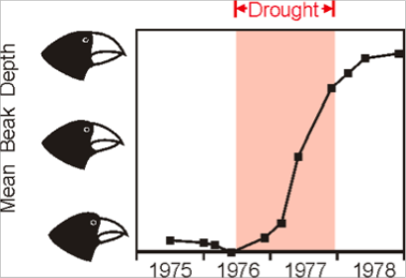

* + During the period of drought, the sizes in beaks increased
  + This was probably because of nuts were getting harder and harder to crack open, therefore a larger beak meant more power to open
  + This does not mean that the heat causes the beaks to enlarge, this implies that the environmental changes influence which traits are “favored” over others
* Example of moths and the industrial revolution:
  + In the Industrial Revolution, there was an uptake in coal/fossil fuel use, casting it into the atmosphere. This in turn lead to more surfaces being blackened with ash. A moth group of two variations native to England had a switch in who was more easily preyed upon. The black moths, which usually stood out on the white buildings, blended nicely into the black facades. The white moths found themselves being eaten more often.
  + **Complex Adaptation:** small steps, each producing minute changes to physiology. These small changes compounded over time result in complex and abstract structures. Eyes were formed in this process.
    - A complex organism was not created all at once according to this theory

**External Links:**

* [What Darwin Never Knew](https://www.youtube.com/watch?v=RpjUHUGDk2Y&list=PL8C4DD85BDC433B90)
* [The Evolution of the Eyes](http://www.youtube.com/watch?v=2ybWucMx4W8)

**What Darwin Never Knew**

* **Tree of Life**: every living creature stems from one organisms and are placed in associative sections with similar phenotypes. All living things are connected.

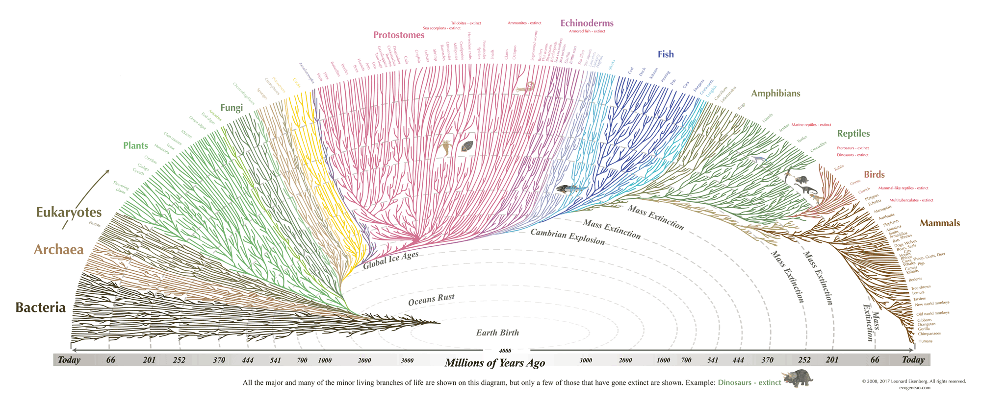

* Variations favored branch off
  + Most of these branches **do not** make it
* **DNA:** Deoxyribonucleic Acid; the structure in which codes for every living creature on Earth
  + 3 things DNA does
    - Replicates (makes more copies of itself)
    - Makes proteins (things that will regulate certain things in the body)
    - Coordinates body growth (puberty, aging, etc)

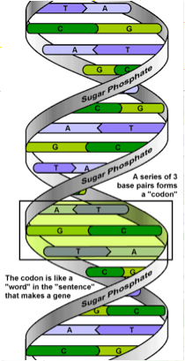

* There are 20 amino acids with specific terminating codons
  + This is similar to programming languages where semicolons are used as delimiters to signal a line break
    - Example: printf(“%s”, “Hello World”);
* **Genes:** Sections of DNA that code for proteins that do specialized tasks
  + **Structural functions**: proteins that make up vital organs and system functions
    - **Hemoglobin**: binds oxygen to red blood cells to allow for oxygen transfer throughout the body
    - **Collagen**: makes up your nails and hair
  + **Regulatory**: making sure your body don’t freak the fuck out
    - **Lactase**: The enzyme that can break down milk products (Lactose)
    - **Alpha Amylase**: found in spit when it turns carbs into sugar
      * Saltine cracker in your mouth example and spit soup example (Amazonian tribe example)
    - **DNA Polymerase**: for replication of DNA
  + **Non-coding**: Most of your DNA does not code for specific things in your body **(98%)**
  + We have 23,000 genes that code for proteins
    - Nothing to freak out about, the number of genes does not dictate superiority
  + **Alleles:** versions of a gene with different phenotypic expressions
    - **Dominant**: the one that is more likely to be shown
    - **Recessive**: the one that is least likely to be shown
  + **Body Plan Genes**: these determine what makes you, you. Like assembling a lego man
    - **Switches:** things that enable/disable certain phenotypic traits (not genes but controller of genes)
    - **Hox Genes**: control the body plan of an embryo along the head-tail axis
  + **NOTE**: Some of the extra DNA are not entirely useless, it can be used for switches that enable and disable genes

**Process of DNA Replication**

* **Transcription**: copying the contents of DNA to an external source, to ensure the source is not tainted
  + Much like creating a tmp file rather than inline editing a file first go (SED)
  + DNA splits into two single strands of RNA which are then ready to be copied
  + **RNA**: ribonucleic acid; makes up ribosomes
  + **microRNA**: regulates genes
    - C, G, A, U (Uracil is in place of Thymine and compliments Adenine)
  + **Messenger RNA**: RNA that contains sections of DNA that must be copied in the cytoplasm
* **Translation**: the act of copying the contents of messenger RNA from the cytoplasm into coherent DNA strands that will be placed into the nucleus of the newly created cell.
  + **transferRNA**: codes in chunks of three anticodons (three nucleotides form one anticodon; a total of nine nucleotides)
    - Sends requests to ribosomes for building supplies in the forms of anticodons
* **Mitochondrial DNA**: This is the DNA stored in the mitochondria and is passed down from mother to offspring. There is one source of mitochondrial DNA and we all share that common ancestor.
* **Haploid cells:** half of the required chromosomes for a fully developed human
* **Germ cells:** created in the testes and ovaries. These are gamete cells created during meiosis (sex cell replication)
* **Zygote:** a fertilized egg cell
* **Diploid genomes:** contains 46 chromosomes; these are found in somatic cells which make up most of the cells in our body
* **Down Syndrome:** when cell replication yields an extra 21st chromosome
* **Mitosis:** when non-sex cells divide. They produce two identical daughter cells

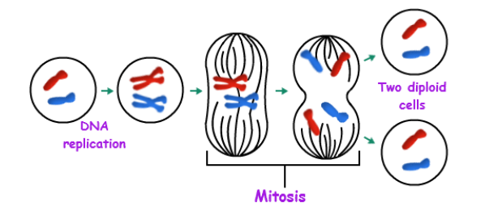

* The “Typical Animal Cell”

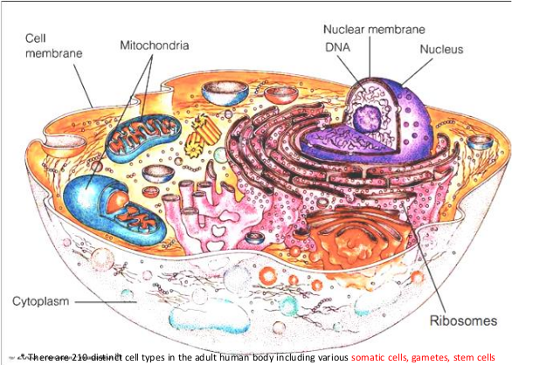

**Mendelian Genetics**

* **Particulate Inheritance:** non-blending inheritance
* **True breeding:** reliably produces same phenotype generation after generation
  + Example: Dogs are sought after to have certain phenotypic traits by humans and pay breeders to produce offspring following that criteria.
* **Alleles:** variants of genes at a single locus. We can follow the distribution of alleles across generations. Law of probability.
* **Unit Factors:** traits are controlled by discrete “particles”
* **Dominance:** the presence or absence of a given phenotype
  + **Dominant**: this trait will be shown unless suppressed by recessive alleles
* **Segregation:** pairs of particles separate into different sex cells with equal likelihood
* **Independent Assortment:** During gamete formation, particles controlling different traits assort independently of each other

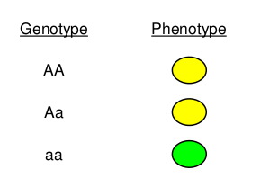

* Expression of phenotypes with a given genotype
* As the amount of generations increase, more combinations of the genotype appear

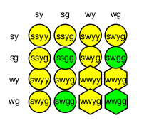

* ^ this is after two generations
* **Crossing over:** bits of one chromosome swapped between members of homologous pair

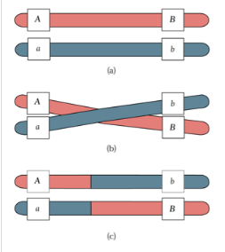

* **Linkage:** genes on same chromosome tend to stay together. The closer together two genes are, the greater the linkage
  + Q: Why?
  + A: Crossing-Over
  + ^ Such a vague answer, thanks professor

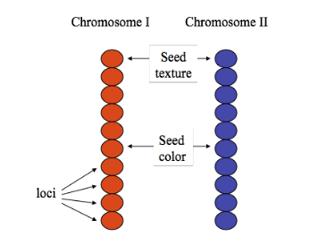

**Myth: Simple Mendelian Traits**

* Previously thought to be Mendelian
  + **Polygenic:** more than just one allele is involved and environmental factors influence phenotype expression
* There is a list of traits listed but ones to look out for
  + Earwax
  + Sickle-cell anemia
  + Huntington disease
  + **Autosomal recessive:** two copies of an abnormal gene must be present in order for the disease or trait to develop
  + **Autosomal dominant:** if you get the abnormal gene from only one parent, you can get the disease
  + Blood type:
    - **Codominant:** of a gene pair in a heterozygote that are both fully expressed
    - ABO blood groups (O is recessive)

**Mutation and Adaptation**

* **“Bad” Mutations:** reduction in the protein’s ability to function causing reduction in fitness (death, inability to reproduce). Most mutations to coding regions are bad (some are just neutral)
* **Neutral Mutations:** the most common kind of mutation. No change in protein formation or slight changes with no effect on reproduction (no contribution to phenotype). CGA-> CGG (alanine)
* **“Good” Mutations:** Increases protein’s ability to function, enhance fitness. Good mutations are very rare, and even more rare that they get passed on and spread.
* **“Bad” vs “Good”** may depend on the environment
* Most mutations are neutral or bad

**From Genotype to Phenotype**

* **Simple**: one to one relationship
  + One gene, one effect
* **Complex**: one to many relationship
  + **Polygenic:** Many genes, one effect
  + **Pleiotropic:** one gene, many traits

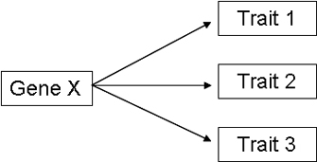

* + Most often, both of these are in effect at once
* **Genotype** → **Phenotype**
* **Qualitative variation:** a measure of statistical dispersion in nominal distributions
* **Point mutations**: affecting only one or very few nucleotides in a gene sequence.
* **Dichotomous traits**:

**Sickle Cell Anemia**

* Malaria resistance
* AA → no anemia; no malarial resistance
* AS → no anemia; malarial resistance
* SS → Anemia; malarial resistance
* **Anemia**: the inability for oxygen bind to hemoglobin on red blood cells
  + When malaria is present, heterozygotes are favored

**ABO Blood Type\***

* Gene on chromosome 9
* O is recessive (you need to have both parents pass down the allele for O)
* A, B are dominant
  + Codominant to each other
* No environment variation effects
* 6 genotypes and 4 phenotypes

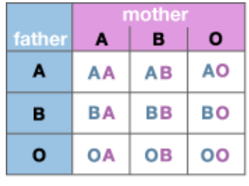

**Quantitative Variation:** exists on a continuum

**Huntington Disease:** caused by the sequence CAG repeated

* 40 to 180 times on chromosome 4
  + **Insertion Mutation:** is the addition of one or more nucleotide base pairs into a DNA sequence
  + **Deletion Mutation:** in which a part of a chromosome or a sequence of DNA is lost during DNA replication

**Obesity:** overweight

* 41 genes were identified as associating with BMI
  + Some affect metabolic activity and appetite regulation
* Food intake is a limiting factor
  + Environmental factors affect how good food tastes
  + Socio economic environment also affect this
* But Crossfit…..

**Note**: populations evolve, not individuals (conjecture to Lamarck’s ideology)

**Evolution:** change in allele frequencies over time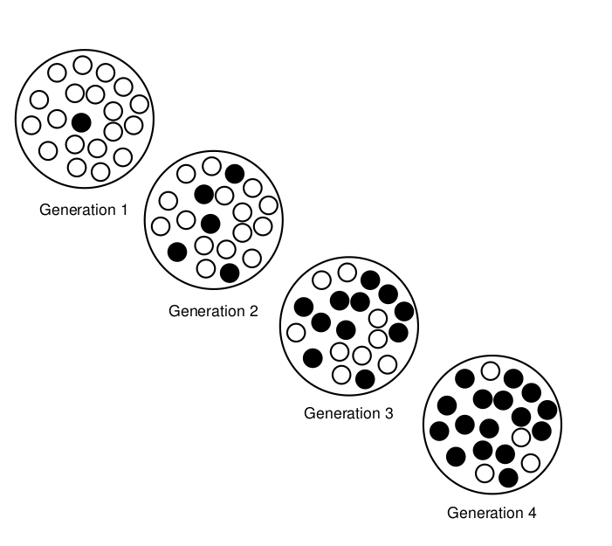

**Note:** there can be one gene and multiple phenotypes (depending on environmental factors will tell how it manifests)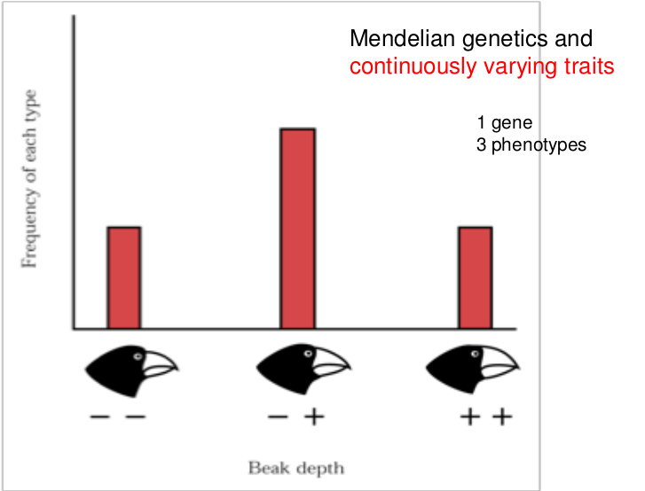

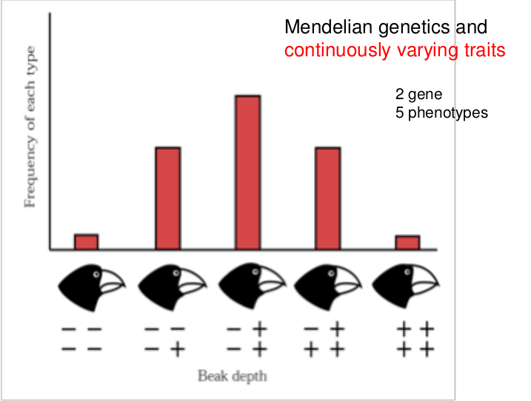

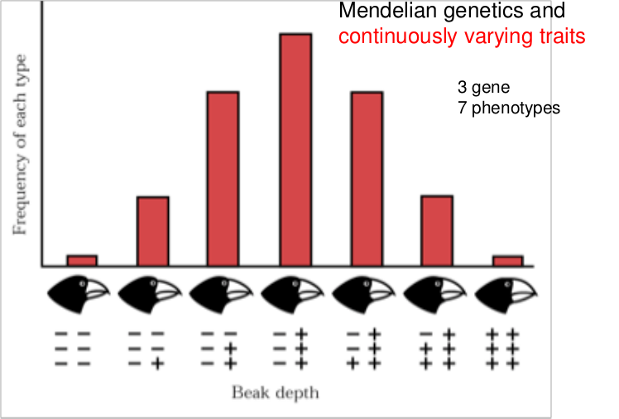

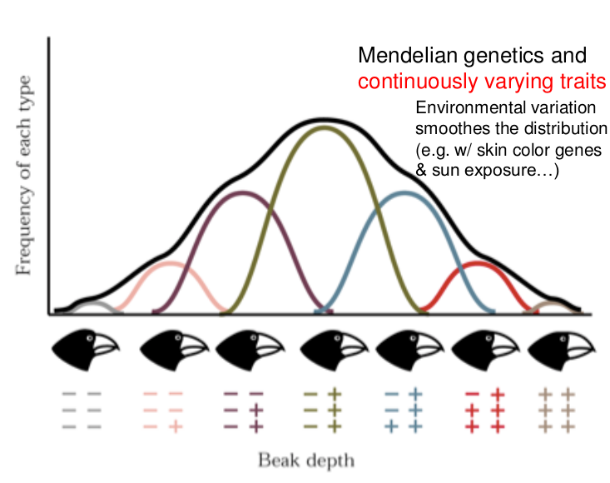

**Mendelian inheritance does not destroy variation:**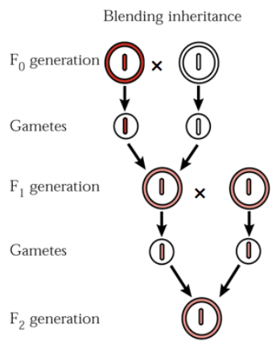

**Variations**

* Essential for selection
* Mutations introduce variation at low rates
* “Hidden” from selection
* Maintained
* Gene pool is also important, along with the visible phenotypes

**Note**:

* Populations evolve, individuals do not
* Natural selection acts on individuals’ phenotypes

**Mutations**

* Several kinds of mutations affect multiple genes in the form of:
  + Deletion
  + Inversion
  + Insertion
  + Translocation
* **This variation can be hidden or expressed**

**Evolutionary reasoning**

* **Adaptive Causes**
  + **Natural Selection**
  + Genetic variation is the raw material for adaptation
  + Selection acts on phenotypes, not directly on genes (different skin colors)
  + **Directional Selection**: extreme traits are favored
    - Examples: peacock feathers, baboons
  + **Stabilizing Selection:** non-extreme traits are favored
  + The effects of selection depend on the environment
    - The UV from the sun
  + Culture also affects the process
    - Sun bathing
  + Sexual selection
    - **Intersexual**: mating with the opposite sex of the same species
    - **Intrasexual**: disputes between the same sex to dictate who gets to have sex with the opposite sex (typically males fight)
    - **Sexual dimorphism:** one major characteristic is exclusive to one gender of the species
      * Example: baboons w/ canines (males have larger pointed teeth)
    - **Obligate costs of reproduction commit females to investing in offspring**
      * Example: it takes around nine months for a human fetus to be fully developed and the body only has enough resources for typically one to two offspring. Males do not need to worry about this refractory period and can essentially have an infinite amount of offspring
      * **Female primates invest a lot into their offspring**
      * **In mammals, males do not invest much in offspring**
        + Humans are the exception

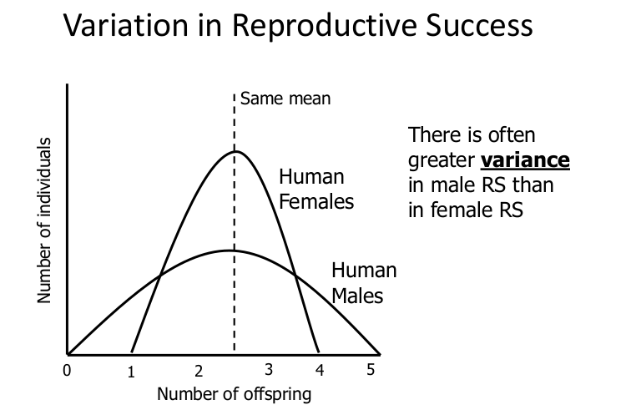

* **Non-adaptive Causes**
  + **Gene Flow**
    - Migration/Separation
    - **Inbreeding**: breeding that occurs when familial members reproduce
    - **Admixture:** two or more previously isolated populations begin interbreeding
  + **Genetic Drift**
    - Small samples vary by chance
    - Population bottlenecks
    - **Founder Effect:** the resulting gene pool that occurs when a new isolated population is founded by a small number of individuals possessing limited genetic variation relative to the larger population from which they have migrated 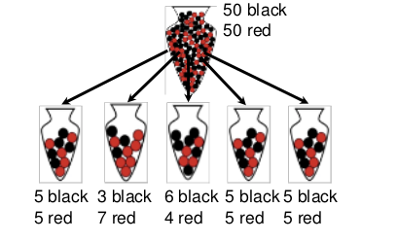

**Why Sex?**

* Why do organisms depend on sex?
  + It feels good (Hedonic pleasure)
  + Family
* Ultimate explanations for why
  + Sexual recombination creates constant new variety or mixes -- ingredients for natural selection to act on (resulting in stable adaptations)
  + **Red Queen**: sex creates constant change with new generations, which keeps disease from achieving greater success
* Gene Flow
  + **Admixture**: allowing for two isolated populations to breed and share their genes into one collective gene pool
* Genetic Drift
  + When two populations that are isolated diverge and develop on their own
* Limiting resources for reproductive success: food, safety, support (most females), access to fertile mates (most males)
  + Tradeoff: mating effort vs. parenting effort

**Levels of Selection**

* Hardy-Weinberg Equilibrium
  + Random mating will not change allele frequencies

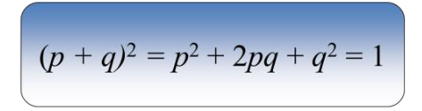

* Genotypic frequencies should remain constant after one generation if there are no forces of evolution at play
* Natural selection will, over time, coerce the population to the habitat they reside in
* It becomes status quo to maintain this equilibrium
* **Group selection:** intuitively appealing at first, but **problem of** mutant invasion by **freeriders**
* Individual selection
* **Inclusive Fitness**(fitness of the gene)
  + Selection based on genes in individual and/or other kin
  + **Kin Selection:** preferences for (closer) genetically related others
  + Coefficient to relatedness (r)
  + **Hamilton’s Rule:** (r * b) > c
  + Formula for when to provide another help (**altruism**)
    - **Altruism**: the belief in or practice of disinterested and selfless concern for the well-being of others.
  + When the benefit of altruism to the recipient
  + Devalued by the degree of kinship
  + Is greater than
  + The cost of providing that benefit for the altruism

**Human Morphology**

* There are variants in the human population
  + Skin color
  + Skull shape
  + Blood groups
  + Teeth
  + Finger prints

**What is Race?**

* Well, it’s complicated
* **Polytypic species:** divided into local populations that differ by one or more phenotypic traits
* **Polymorphisms:** Traits for which two or more distinct phenotypes exist within a population
* Variation can occur within or between groups
  + Most of the diversity can be found within a group rather than between multiple groups
* Individuals vary because:
  + Phenotypic differences
  + Genetic differences
  + Environmental differences
* Twin studies can isolate genetic effects
* Causes of genetic variation
  + **Within**:
    - Balanced polymorphism
      * Example: Selection maintains variation as heterozygotes are resistant to malaria
    - Mutation-selection balance
      * Constantly introducing the recessive alleles at low rates
      * Selection eliminates homozygote recessives
    - Evolutionary disequilibrium
  + **Between Groups:**
    - Natural Selection
    - Genetic Drift